

Year 10 (Grade 9) Pre-Test

English First Language

Instructions:

You have 60 minutes to complete this exam. Please write your name and school below and answer all of the following questions carefully.

Name:

_____________________________________________________________________

School:

_____________________________________________________________________

Score: _____/25
Instructions:

This exam is one question on an undisclosed poem. Read the following poem carefully. Then answer the essay question on page 3. In your answer, you should:

- explore the poet’s use of language, including imagery and word choices

- analyse how structure and form help to convey the poet’s message

- show an understanding of the attitudes and values expressed in the poem

- support your ideas with carefully chosen references to the poem

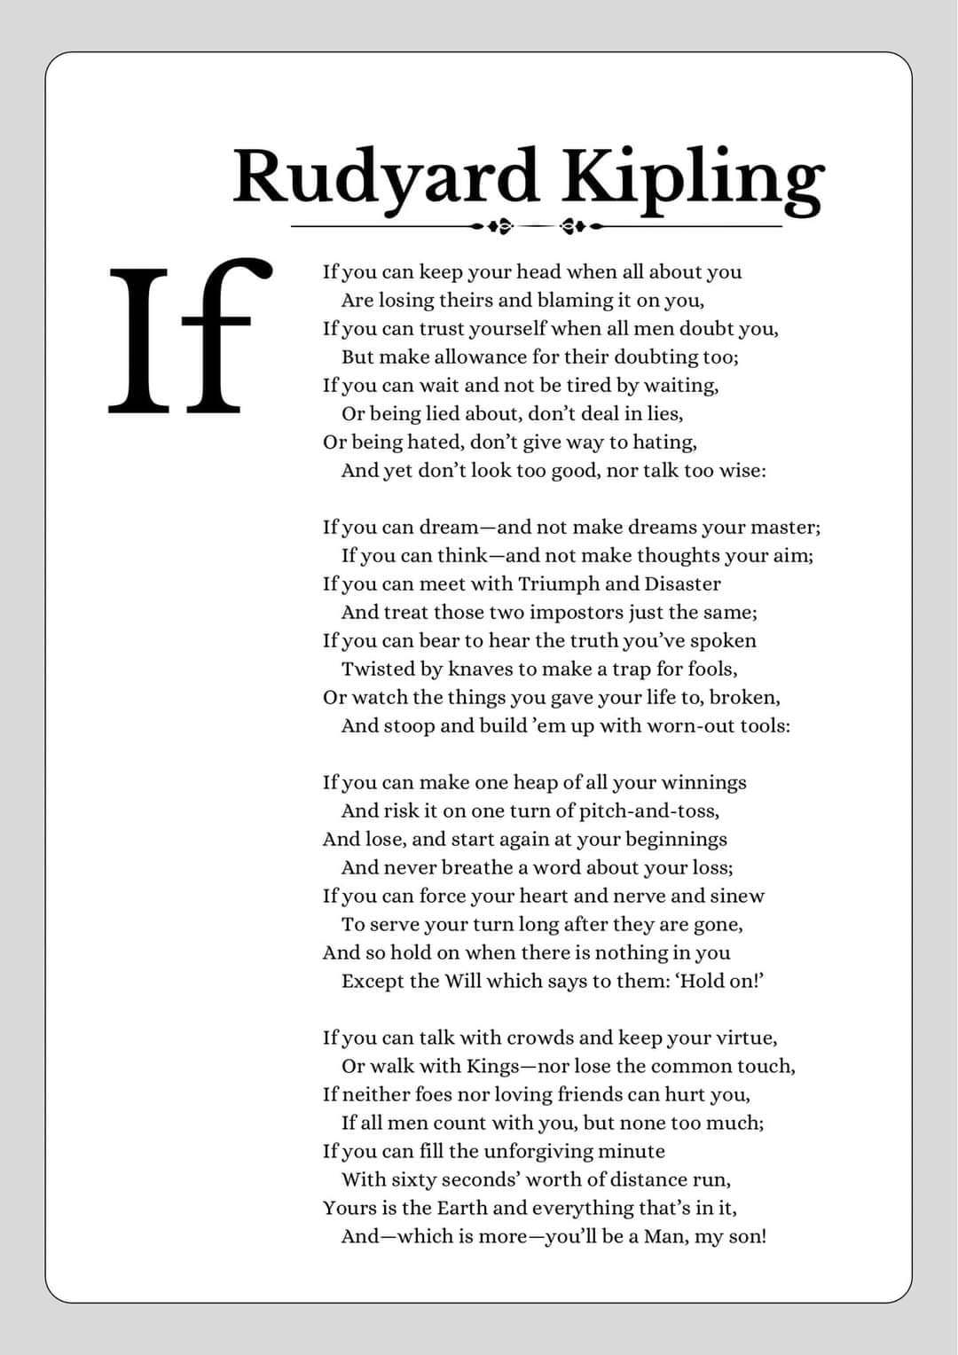
Question:

To what extent do you think the poet’s ideas about character are still relevant today?

Please write a minimum of 300 words. You may use the space below to plan and you may start writing on the following page.

Planning space:

____________________________________________________________________________

____________________________________________________________________________

____________________________________________________________________________

____________________________________________________________________________

____________________________________________________________________________

____________________________________________________________________________

____________________________________________________________________________

____________________________________________________________________________

____________________________________________________________________________

____________________________________________________________________________

____________________________________________________________________________

____________________________________________________________________________

____________________________________________________________________________

____________________________________________________________________________

____________________________________________________________________________

____________________________________________________________________________

____________________________________________________________________________

____________________________________________________________________________
Write your essay here:

____________________________________________________________________________

____________________________________________________________________________

____________________________________________________________________________

____________________________________________________________________________

____________________________________________________________________________

____________________________________________________________________________

____________________________________________________________________________

____________________________________________________________________________

____________________________________________________________________________

____________________________________________________________________________

____________________________________________________________________________

____________________________________________________________________________

____________________________________________________________________________

____________________________________________________________________________

____________________________________________________________________________

____________________________________________________________________________

____________________________________________________________________________

____________________________________________________________________________

____________________________________________________________________________

____________________________________________________________________________

____________________________________________________________________________

____________________________________________________________________________

____________________________________________________________________________

____________________________________________________________________________

____________________________________________________________________________

____________________________________________________________________________

____________________________________________________________________________

____________________________________________________________________________

____________________________________________________________________________

____________________________________________________________________________

____________________________________________________________________________

____________________________________________________________________________

____________________________________________________________________________

____________________________________________________________________________

____________________________________________________________________________

____________________________________________________________________________

____________________________________________________________________________

____________________________________________________________________________

____________________________________________________________________________

____________________________________________________________________________

____________________________________________________________________________

____________________________________________________________________________

____________________________________________________________________________

____________________________________________________________________________

____________________________________________________________________________

____________________________________________________________________________

____________________________________________________________________________

____________________________________________________________________________

____________________________________________________________________________

____________________________________________________________________________

____________________________________________________________________________

____________________________________________________________________________

____________________________________________________________________________

____________________________________________________________________________

____________________________________________________________________________

____________________________________________________________________________

____________________________________________________________________________

____________________________________________________________________________

____________________________________________________________________________

____________________________________________________________________________

____________________________________________________________________________

____________________________________________________________________________

____________________________________________________________________________

____________________________________________________________________________

____________________________________________________________________________

